|  |  |
| --- | --- |
| Date | 15th April 2023 |
| Team ID | NM2023TMID16773 |
| Project Name | Job Application Tracking System |
| Team Leader | SOWMIYA.S |
| Team Member | ABINAYA.S |
| MAHALAKSHMI.S |
| YOGASRI.V |

1. **INTRODUCTION**
   1. **. Overview**

An applicant tracking system (ATS) is software for recruiters and employers to track candidates throughout the recruiting and hiring process.

* 1. **. purpose**

Their main purpose is to streamline certain tasks and increase efficiency when hiring or interviewing a large group of job candidates.

An ATS allows the hiring manager to list job descriptions manage applications, choose interview candidates and move forward with the hiring process.

1. **PROBLEM DEFINITION & DESING THINKING**

**2.1. Empathy map**

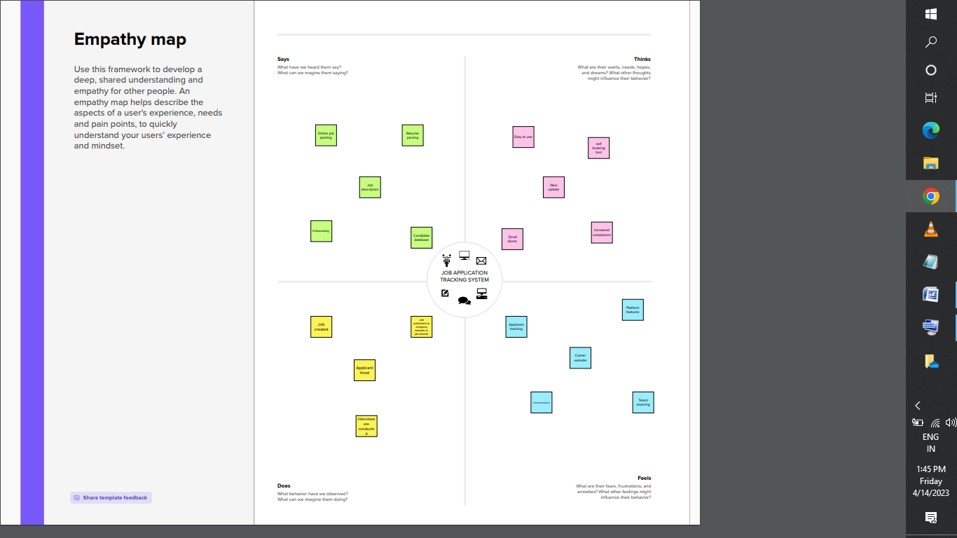

**2.2. Ideation & Brainstorming Map**

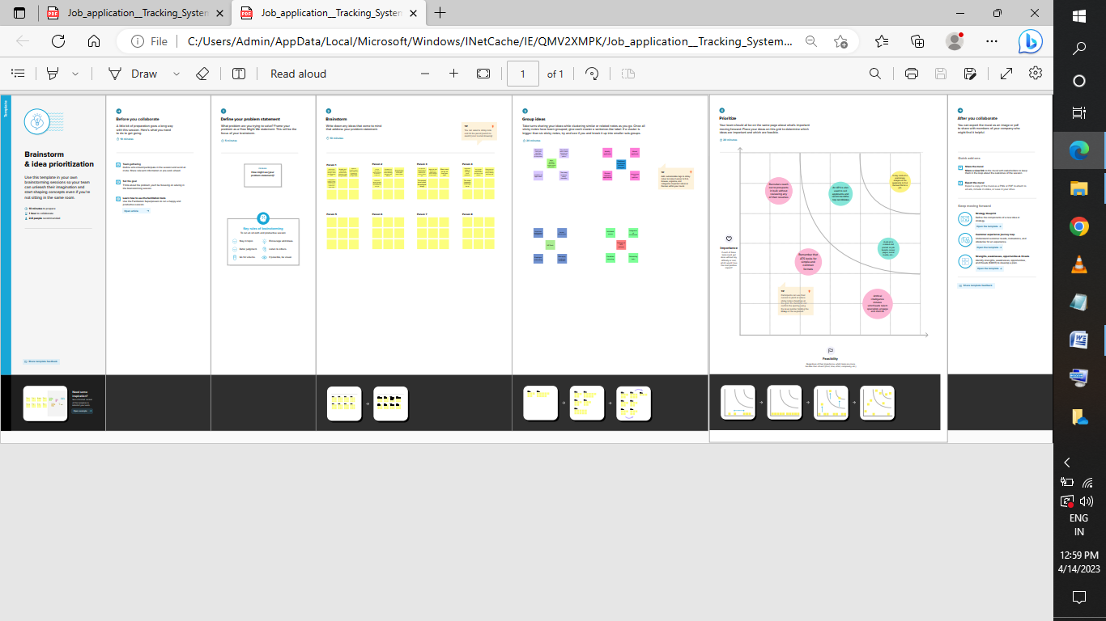

1. **RESULT**

**3.1. Data Model:**

|  |  |  |
| --- | --- | --- |
| **Object name** | **fields in the Object** | |
| **Field Label** | **Date Type** |
| Recruiter | Job Tittle | Text |
| Jobs | Recruiter | Text |
| Description | Description | Text |
| Location | Location | Text |
| Tabs | Tabs | Text |
| Profile | Profile | Text |
| Sharing setting | Candidate | Text |

**3.2. Activity & Screenshot**

Milestone 1:

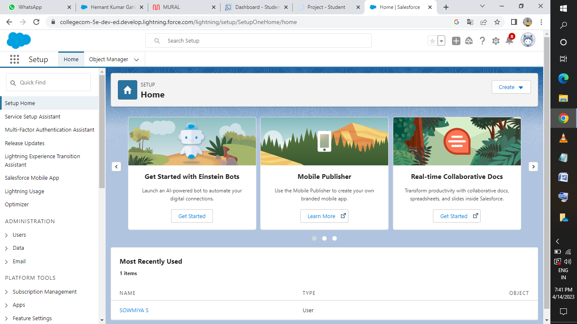

Milestone 2: 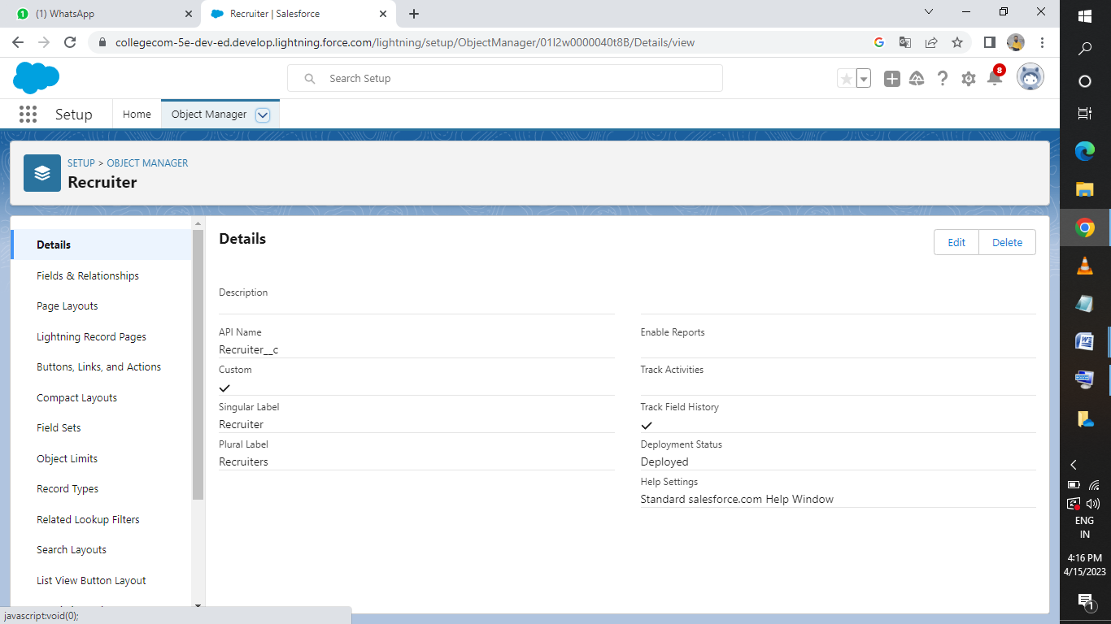

Milestone 3:

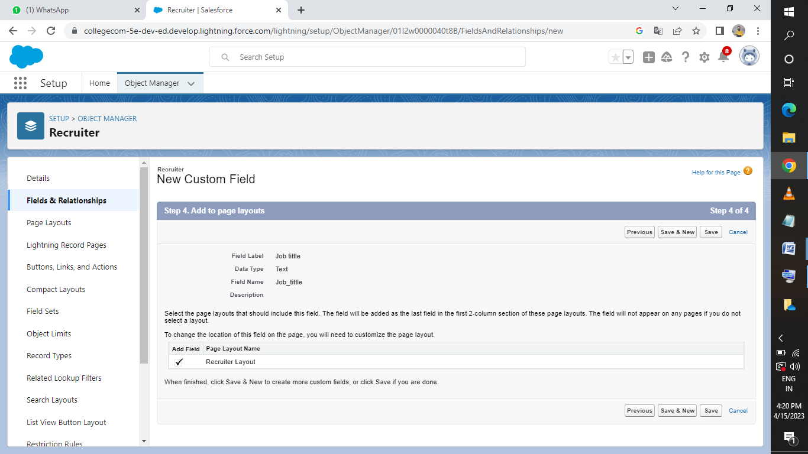

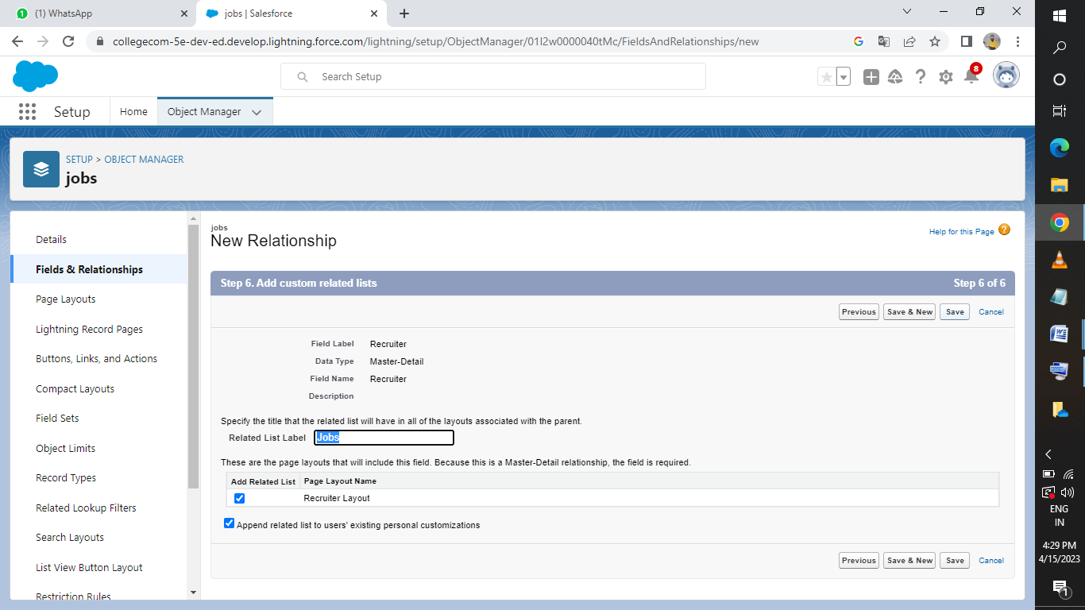

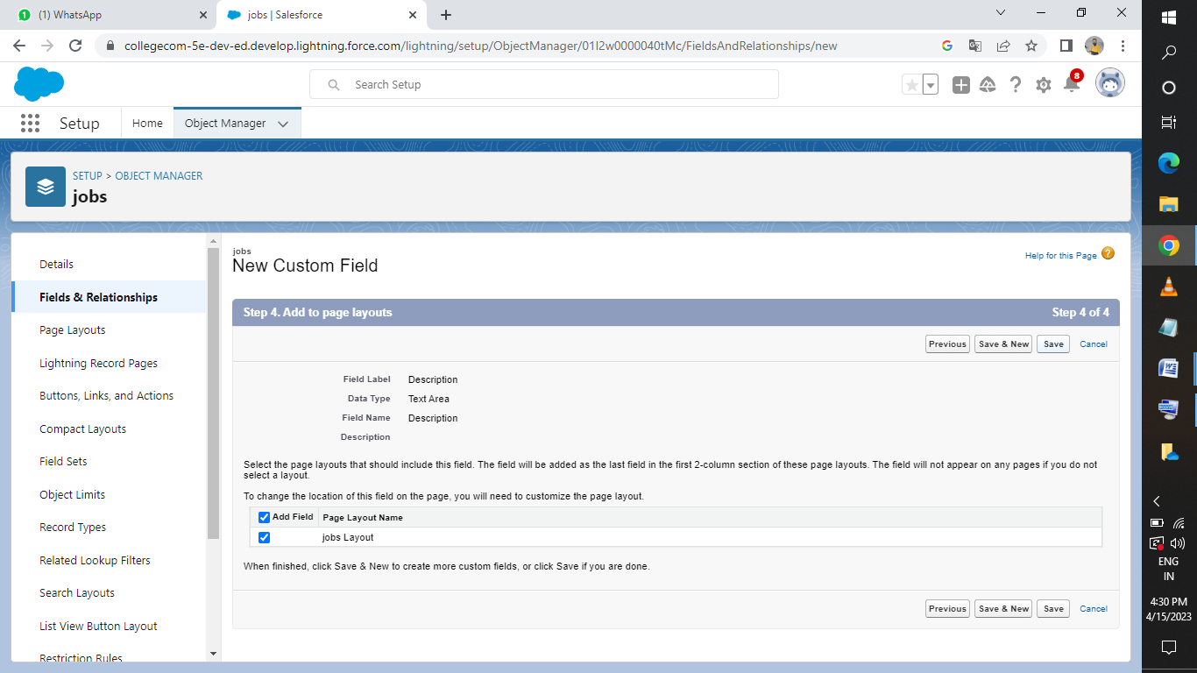

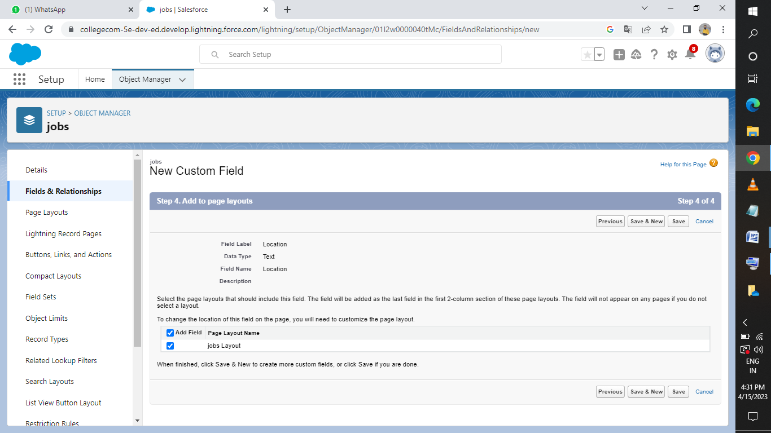

Milestone 4:

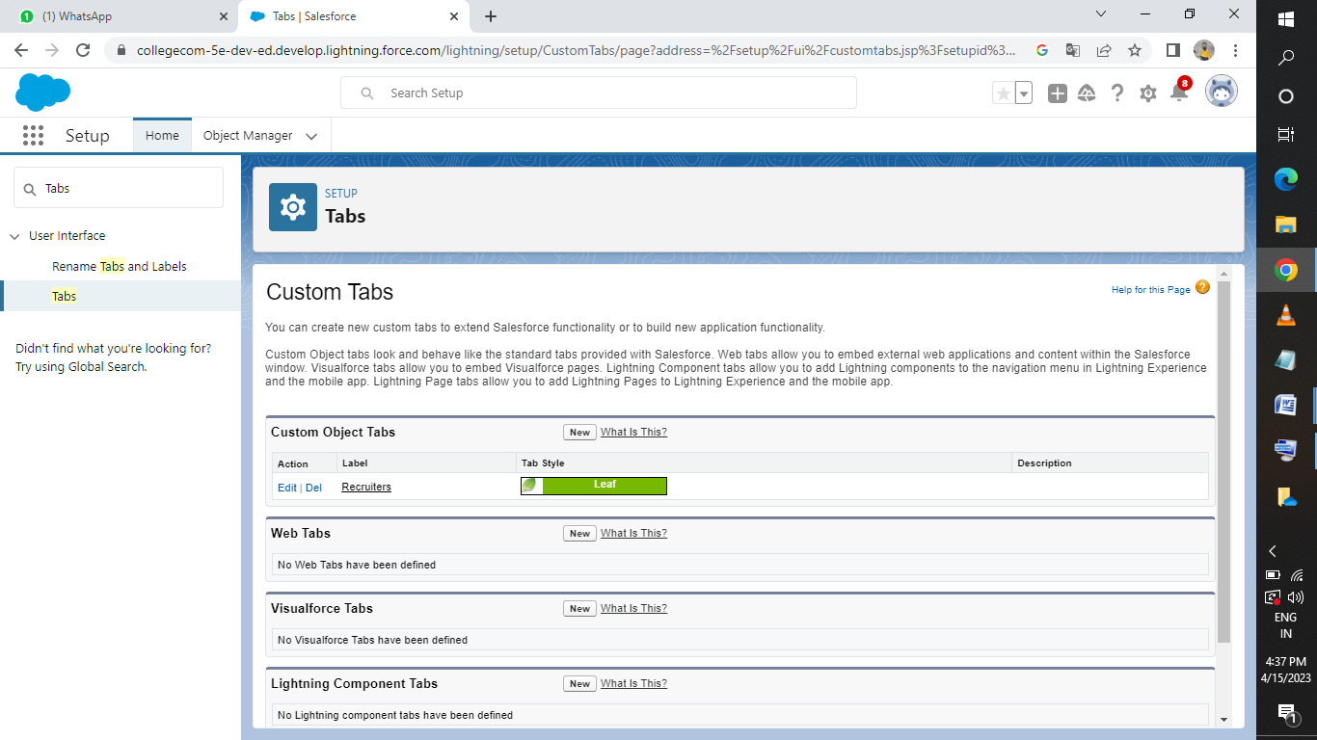Milestone 5:

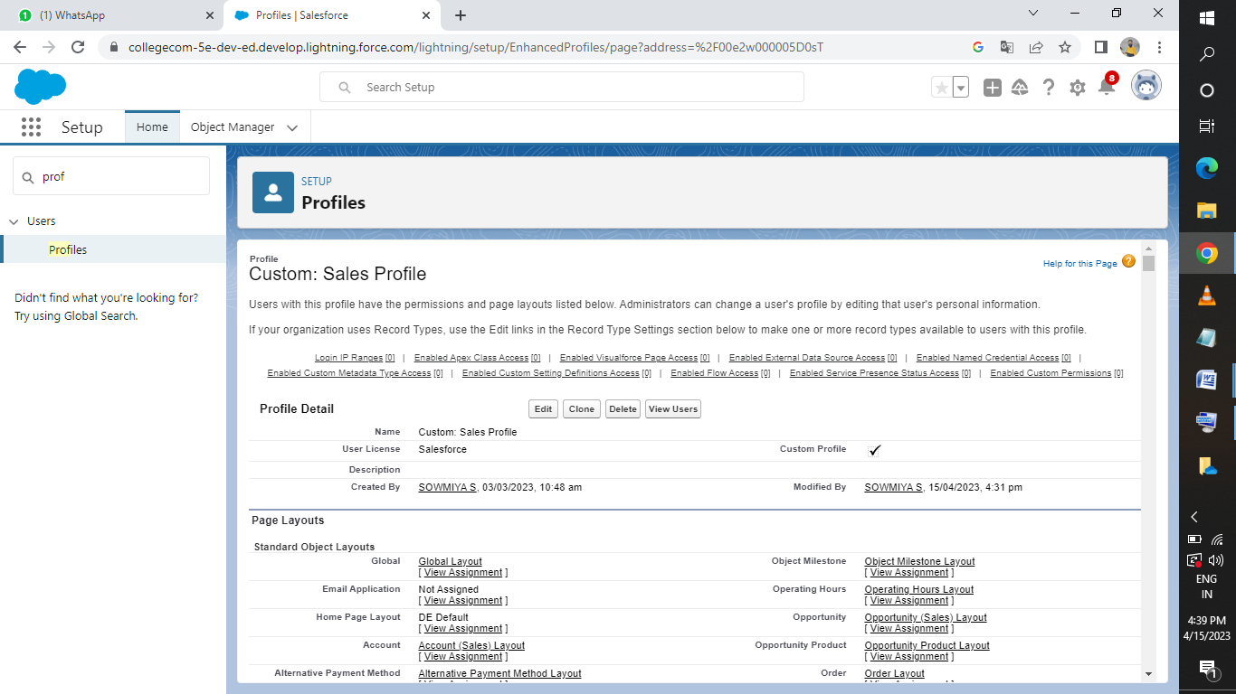

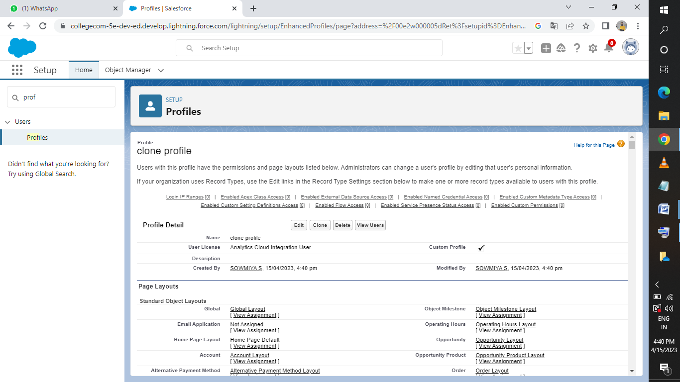

Milestone 6: 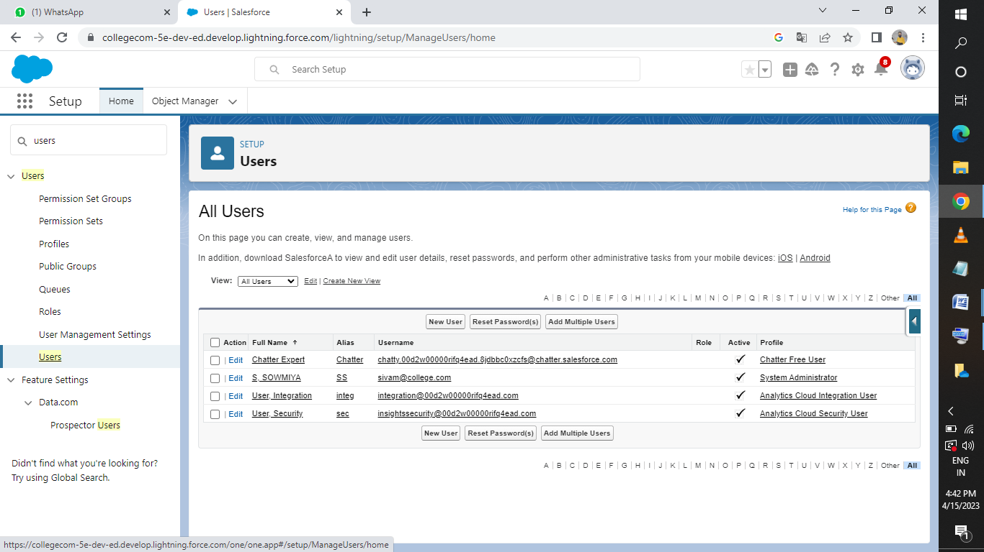

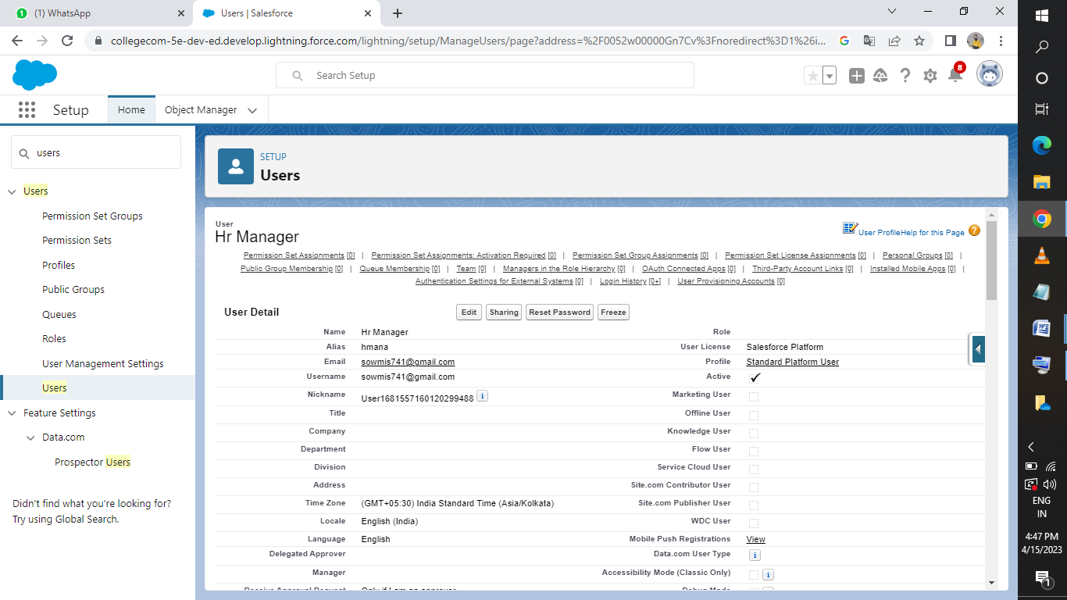

Milestone 7:

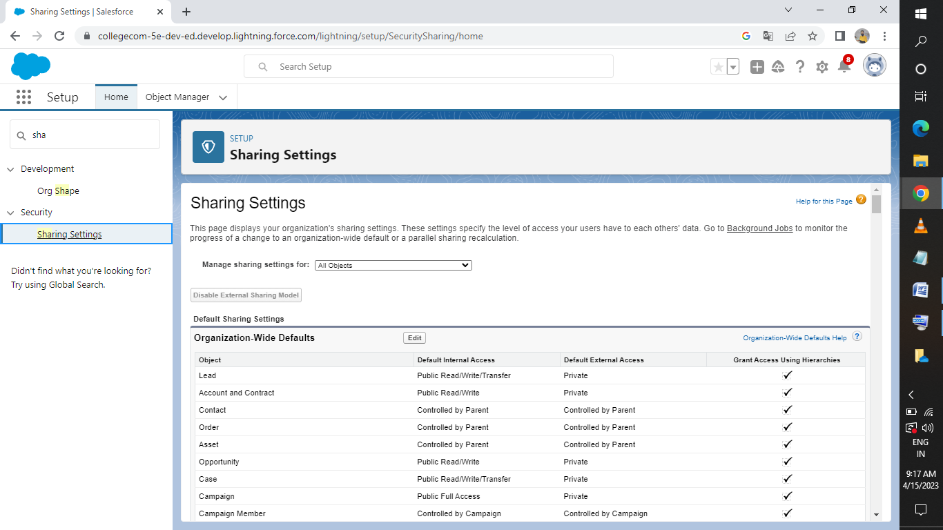

Milestone 8:

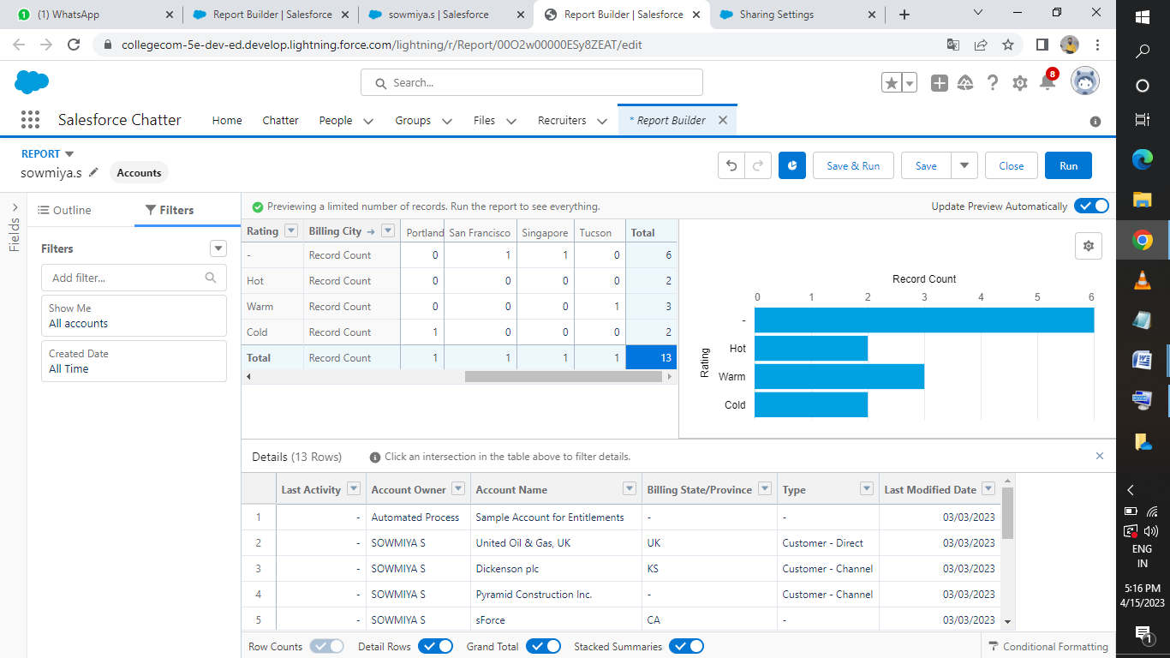

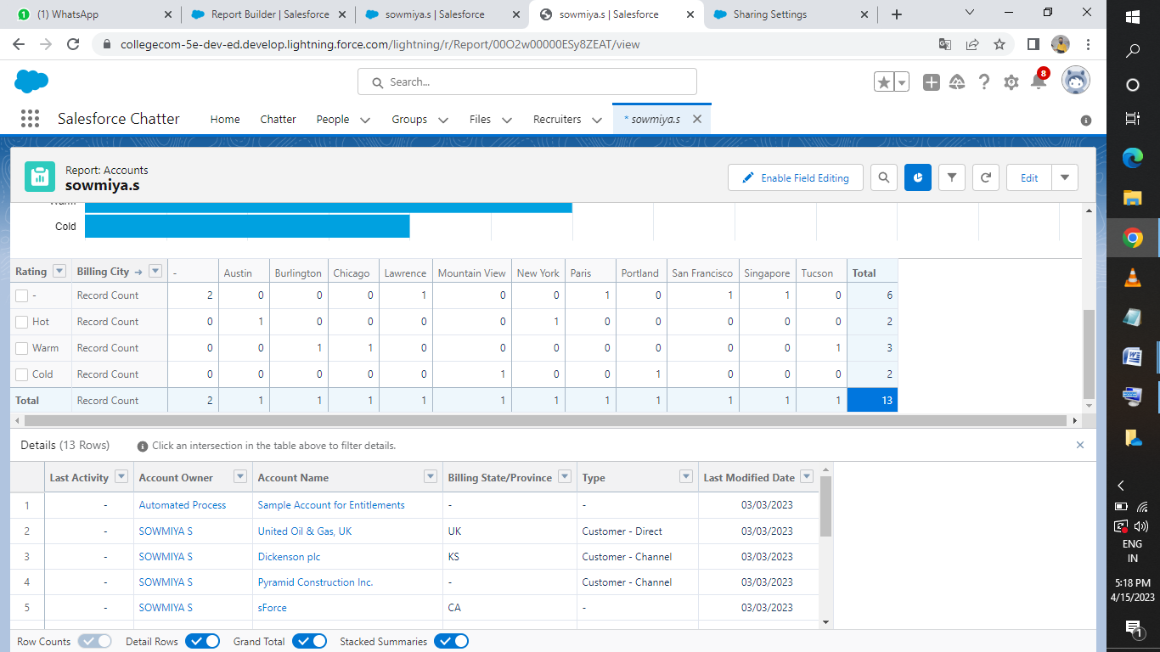

1. **TRAILHEAD PROFILE PUBLIC URL**

**Team Lead –** [**https://trailblazer.me/id/sowms29**](https://trailblazer.me/id/sowms29)

**Team Member 1 –** [**https://trailblazer.me/id/abins31**](https://trailblazer.me/id/abins31)

**Team Member 2 –** [**https://trailblazer.me/id/mahas67**](https://trailblazer.me/id/mahas67)

**Team Member 3 –** [**https://trailblazer.me/id/yogav7**](https://trailblazer.me/id/yogav7)

1. **ADVANTAGES & DISADVANTAGE**

**Advantages:**

**Reduces time spent on admin tasks:**

ATS software allows you to automate various tasks of the hiring process that can save you a lot of time and free up your recruiting personal for other high value tasks

**Resume and CV screening:**

With recruiters receiving loos of resumes per role, even scanning can take a lot of time.

The number of resumes a recruiters needs to review can be reduced drastically using pre-screening questions or word searches within resumes.

Once, again a recruiters time can be redirected to higher value items of the business.

**Speeds up the recruitment cycle:**

Having candidates information centralized on a single platform gives recruiters access to organized information allowing them to review and compare candidates more easily and quickly which leads to lower cost-per-hire.

**Improves the quality of hire:**

First, you were able to cast a wider net by posting on job boards with standardized messaging to attract more candidates.

Second you used automated matching and filtering weed out unqualified candidates.

Both benefits saved you or your recruiter the time necessary an gather more insightful information.

**Disadvantages:**

**Could filter out good candidates**

When “programming” your recruiting software to recognize common keywords around roles and responsibilities, you could end up filtering out good candidates.

This can happen with manual reviews as well, so automation in most situations, has a net benefit.

**Communications can be less personalized:**

When automating response to candidates, your messaging will be less personalized and can come off as robotic.

Taking additional time to construct good communication can help make it feel more personalized.

1. **APPLICATIONS**

When applicants apply for a job online, their contact information, experience, educational background, resume and cover letters are uploaded into the database.

The system allows company recruiters to review the applications send applicants automated messages letting them know their applications have been received and give online tests.

1. **CONCLUSION**

Hiring managers and recruiters reply on their ATS software to shortlist a handful of candidates from hundreds of applications they may receive for a single job posting.

Apart from helping recruiters collect information in one place, an ATS may help schedule an interview, perform reference checks and complete important paperwork.

An applicant tracking system can benefit recruit in many ways, such as,

* Save time
* Filters candidates
* Facilitates collaborative hiring
* Ensure betters tracking
* Increases quality of hire

1. **FUTURE SCOPE**

ATS value comes from being agile to rapidly push out of job descriptions to free and paid boards.